
Assessment cover

STUDENTS, PLEASE COPY THIS PAGE AND USE AS THE COVER FOR YOUR SUBMISSION

Module No: | ENGR6013 | Module title: | Engineering Project

Assessment title: | Project Plan

Banner assignment identifier | CWS1WEEK5 | Due date and time: |  | 13:00 on Friday Week 6 Part 1 S1.  Supervisor to submit Part 2 by Friday Week 10 S1
Student name |  |  | Matt Roche
Student number |  |  | 19141411

Estimated total time to be spent on assignment: | 30hrs

On successful completion of this assignment, students will be able to achieve the following learning outcomes (LOs):
Prepare a plan of work to effectively design or investigate an engineering related problem and present this in the form of a written project plan. Formulate a detailed Gantt chart that can be used to organise and execute the project.
Evaluate, compare and contrast engineering practice using published literature to develop and inform project methodology.
Demonstrate the ability to select and apply a range of innovative and standard techniques to solve problems and evaluate system or design performance in the context of a major project.
AHEP4 LEARNING OUTCOMES

Engineering Council AHEP4 LOs assessed (from S1 2024 Onwards)
LO number | LO text
C4 | Select and evaluate technical literature and other sources of information to address complex problems
C5 | Design solutions for complex problems that meet a combination of societal, user, business and customer needs as appropriate. This will involve consideration of applicable health and safety, diversity, inclusion, societal, environmental and commercial matters, codes of practice and industry standards
C7 | Evaluate the environmental and societal impact of solutions to complex problems and minimise adverse impacts
C8 | Identify and analyse ethical concerns and make reasoned ethical choices informed by professional codes of conduct
C9 | Use a risk management process to identify, evaluate and mitigate risks (the effects of uncertainty) associated with a particular project activity.
C10 | Adopt a holistic and proportionate approach to the mitigation of security risks.
C13 | Select and apply appropriate materials, equipment, engineering technologies and processes, recognising their limitations.
C15 | Apply knowledge of engineering management principles, commercial context, project and change management, and relevant legal matters including intellectual property rights.
C17 | Communicate effectively on complex engineering matters with technical and non-technical audiences.
C18 | Plan and record self-learning and development as the foundation for lifelong learning/CPD
Statement of Compliance
By submitting this assessment I declare that the work submitted is my own and that the work I submit is fully in accordance with the University regulations regarding assessments. (www.brookes.ac.uk/uniregulations/current)
Use of AI Tools: You are required to use this form to declare which AI tools you have used and how you have used them. Please complete the form and attach it to your submission as an Appendix, if you have used such tools.

FORMATIVE FEEDBACK OPPORTUNITIES
As part of this work, students will have the opportunity to submit a draft of part 2 of the project plan. The draft will be reviewed, and students will receive individual feedback. Students are also encouraged to make use of drop-in hours and supervision sessions (and similar) to ask questions.

SUMMATIVE FEEDBACK DELIVERABLES
Deliverable content and standard description and criteria | Weighting out of 100%
Assessed report | 100%


  - Matt Roche
  - 19141411
Word Count: 2219

Application and Design of a Training Sensor system to Estimate Input Power for Racing Wheelchair Athletes
Contents
1. Introduction 5
1.1 Definitions and Abbreviations 5
1.2 History and Justification 5
1.3 Aims and Objectives 6
1.3.1 Project Aim: 6
1.3.2 Project Objectives: 6
2. Literature Review 7
2.1 Use of power in training 7
2.2 Biomechanics of Wheelchair racing 7
2.3 Applications of IMU Based power meters 7
3 Research Methodologies 8
3.1 Project flow Diagram 8
3.2 System Block Diagram 9
4 Planning 10
4.1 Tasks 10
5 Project Risks 12
6.1 Risk Matrix Pre Mitigation 12
6.2 Risk Matrix Post Mitigation 12
6 Summary 13
7 References 14
8 Appendices 15
.1 Appendix A 15
9.1.1 Gantt Chart 15
9.2 Appendix B 18
9.2.1 Risk Table 18

Introduction

1.1 Definitions and Abbreviations

ISMGF - International Stoke Mandeville Games Federation | IOC - International Olympic Committee
IMU – Inertial Measurement Unit | CAD – Computer Aided Design
CAD – Computer Aided Design | PCB – Printed Circuit Board
MEMS - Micro Electronic Mechanical Systems | IC – Integrated Circuit
BL – Bluetooth | SPI – Serial Peripheral Interface
BLE – Low Energy Bluetooth | I2C - inter-integrated circuit

1.2 History and Justification
In 1952 the first organised International Wheelchair Sporting competition took place and would cement ties between the International Stoke Mandeville Games Federation (ISMGF), so named for the hospital where wheelchair sports were first used for rehabilitation, and the International Olympic Committee (IOC). Shortly after the first international games for the disabled took place in 1960, and was named the Paralympics in 1964. (Cooper, 1990) Since then the world of wheelchair sports has broadened greatly. Where almost all conceivable sports have a wheelchair or “sit chair” equivalent, from tennis and lacrosse to sailing and athletics.
When looking at the advancement of training in other cyclic wheeled sports we see that since the introduction of power meters in the 1980s, training has changed dramatically, this introduction to data as a training tool has become standard practice in almost every cycling discipline. (Leo et al., 2022) These sensors leverage the crank sets as a simple position to instrument with strain gauges and gyroscopes.
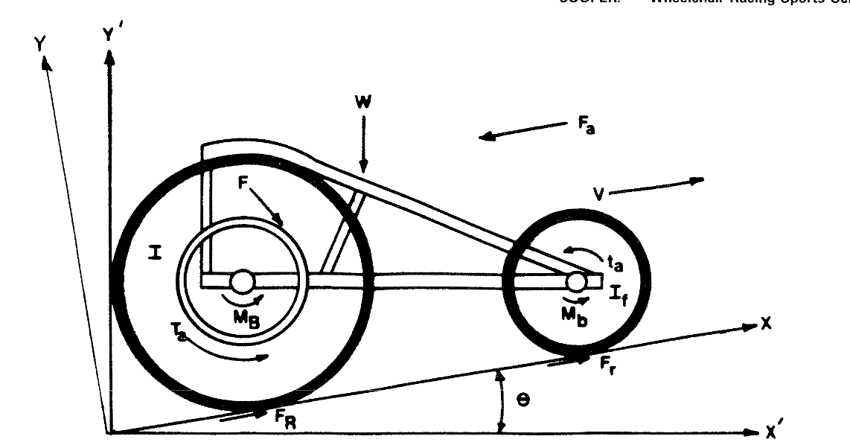
Figure 1 (Cooper, 1990) Freebody diagram of a racing chair
However, work on Wheelchair Power meters is limited and their use in the field is limited to none. Further development of more portable instruments to collect mechanical, data during actual training is required (Cooper, 1990). IMU based power meters has been demonstrated by (Dijk et al., 2024) this system holds only under perfect conditions with no environmental factors. This technology is yet to be applied in the field for training assistance. With the mass adoption in other cyclic sports of this technology, the hope is that this could increase the training validity of athletes in this field and assist coaches in development of training and nutrition plans.

1.3 Aims and Objectives

1.3.1 Project Aim:

Explore and develop a sensor installation, that estimates average input power for use in wheelchair sports and training with the aim to confidently display a measure of athlete input using data collected on road, wind and setup conditions. The aim is for this value to be consistent, to aid in training, as such the value need only be a reasonable estimation of the input so long as the error is carried across multiple use tests.

1.3.2 Project Objectives:

- Develop a simplified theoretical model of an athlete wheelchair system with an Inertial Measurement to compare theoretical to a developed sensor installation. This model should consider simplified losses, wind, rolling and frictional losses to compare to a ‘real world’ test. (Mid-November)

- To design and build a sensor installation able to measure: vehicle speed, oncoming air speed and heading. To actively quantify the environmental factors acting on the system in the field. The aim of this is to produce an accurate mass and package space efficient sensor prototype. That will allow for active athlete power calculation. (Early-December)

- To design and build an IMU sensor to determine input work from the athlete. This is in essence a sensor measuring the linear accelerations of the chair, this will then be used to determine a power value using the environmental data collected by the system. This sensor will also indicate the inclination of the surface to a zeroed value. (Early-December)

- Determine algorithms for this input power estimation within the system firmware and store outputs in a file format for later analysis. (Early-January)

- Develop a rundown test for determining in field rolling resistance. This test would be used to calibrate the system to multiple working surfaces, in this iteration the system will store only one resistance measurement. (Early-February)

- Test the system and analyse data from in field testing. This could be done using an analogous vehicle for example a bicycle with limited updates to the sensor firmware for a reasonable estimation to the host vehicle. (Mid-February)

Literature Review

In this short literature review an examination of the use of power data in sports training specifically the impact on sports coaching and the data methodologies at large. Also, the biomechanics of wheelchair racing itself establishing the basis of the theory of energy balance for input power estimation and the essence of the system numerical validity, Finaly existing applications of Inertial measurement in athletics, with focus on usage for power estimation.

2.1 Use of power in training
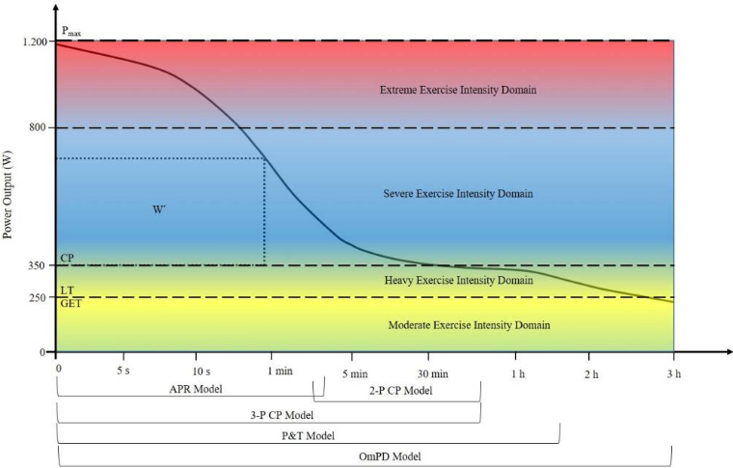
Power meters used in other sports, very prominently in cycling, allow detailed analysis of individual cyclists and their individual training requirements, providing the required data for more and more individualised training plans. A key use of this data is ‘power profiling’ often defined by evaluation if in field derived data (Leo et al., 2022). This data is used to create commonly a ‘Power-Duration’ Relationship to evaluate athlete power profile shown in Figure 2 (Leo et al., 2022). The intention behind the work done in this project is to allow wheelchair athletes and their coaches to undertake a similar approach in training.
Figure 2 (Leo et al., 2022). A graph of power output vs time under load, illustrated bellow is the relative models often used to derive each section of the illustration

Biomechanics of Wheelchair racing
Literature on the biomechanics of wheelchair racing is relatively rich. Key information required to progress this project is understanding the energy losses involved in the athlete chair system. The work of (Silveira et al., 2022) reviews of resistive and propulsive forces, reviews the methods of determining these factors, including aerodynamic drag and rolling resistance, including recommendations for analytical approach. Work done by (Barbosa et al., 2016) utilised roll down tests to estimate, coefficient of rolling friction and effective aerodynamic area, this research also describes the mathematical approach taken, this will outline the numerical approach. (Forte et al., 2018) performed computational fluid dynamics on different parts of the stroke, showing that aerodynamic drag is non uniform throughout the stroke cycle. The paper (Coelho et al., 2018) also examines the losses in rolling resistance and aerodynamic drag, using a scanned model of and athlete chair system, and supplies values for losses to aerodynamic drag and mechanical resistance, giving analytical methods for deriving total power and energy cost.

2.3 Applications of IMU Based power meters
The work of (Dijk et al., 2024) demonstrates use of the energy balance theory using IMU sensors to determine input power. The paper defines a theoretical framework and modelling of the athlete and the wheelchair. Also examined are the required assumptions for this system to work, and the overall accuracy. The system described in this paper shows validity for indoor usage. This paper is the basis for the system developed in this project, taking the system proposed and increasing the use case to outdoor wheelchair racing.

Research Methodologies
The following shows the project development flowchart encompassing details on the early design phases through to the detailed design, and finally testing phase. Initial development is a first principles approach to develop development units to do continuous testing as the software becomes more fleshed out. Key early decisions need to be made based on research are, Modelling software and Sensor Development software. Alongside that continuing literature review to determine appropriate estimate factors.

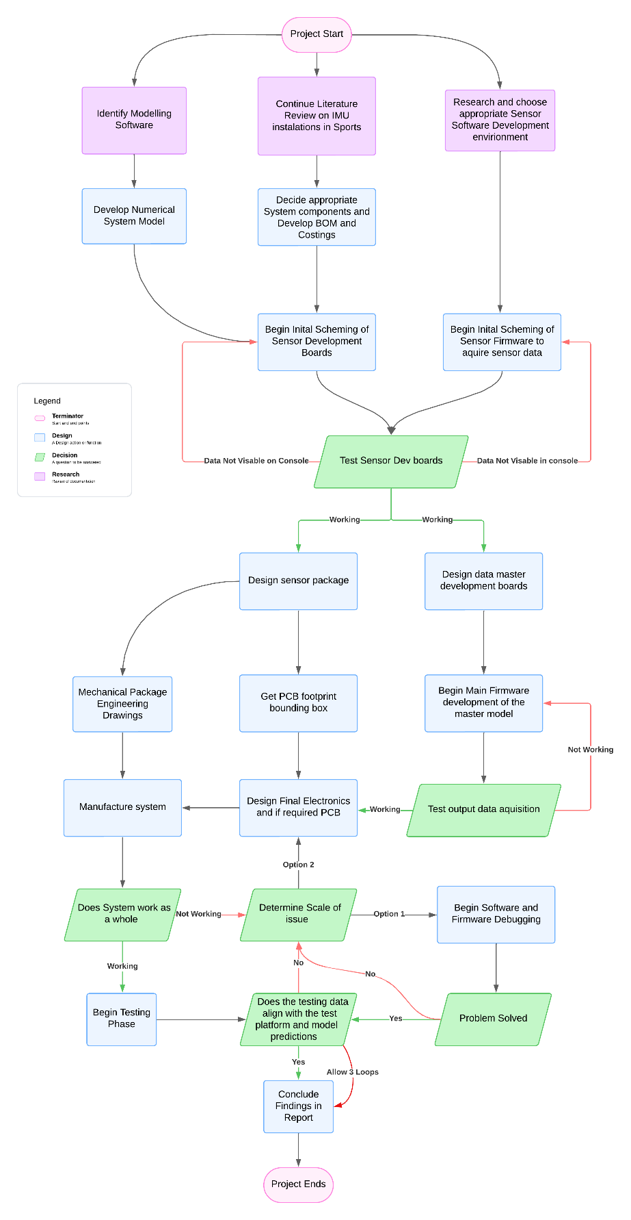
3.1 Project flow Diagram

Figure 3 Project Flow Diagram

3.2 System Block Diagram
Figure. 3 Show as potential sensor block diagram, with potential inclusion of Bluetooth integration to ‘Garmin’ or other cycling computers.

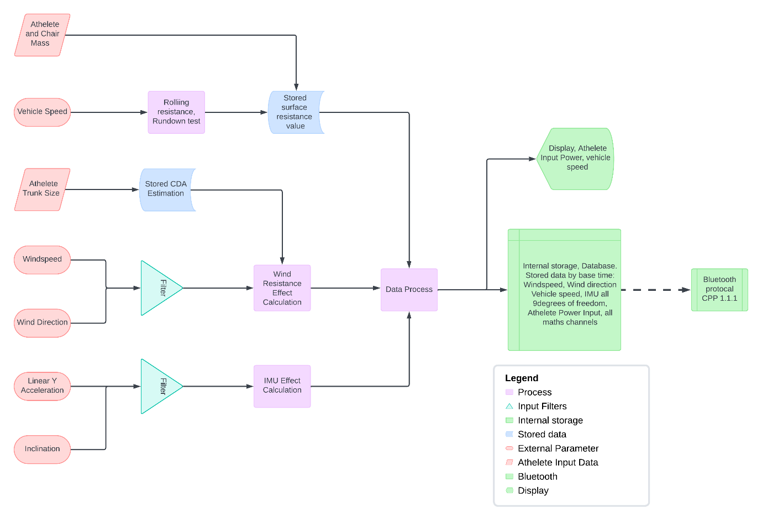
Figure 4 Sensor Flow Diagram

Planning
The following sections describes the project plan in detail, shown in Appendix A 9.1 is a Gantt chart detailing the project timings and runway. In section 4.1 table 1 shows a detailed description of the tasks required to complete the objectives as stated, and the resources required to complete each task.

4.1 Tasks
Table 1 Detailed task outline with respect to aims
Objectives | Task Number | Task Description | Resources
Develop a Numerical model of an athlete wheelchair system | 1 | Identify Modelling Software
 | 2 | Research appropriate modelling strategies | Books, Journals, Articles
 | 3 | Research racing chair aerodynamics and rolling resistance | Books, Journals, Articles
 | 4 | Model simple Aerodynamic and rolling resistance Model | Books, Journals, Articles and Modelling Software
 | 5 | Model Input characteristics | Books, Journals, Articles and Modelling Software
 | 6 | Create Athlete Pushing model | Books, Journals, Articles and Modelling Software
 | 7 | Increase Aerodynamic Model Complexity, adding Yaw and any other desired factors identified | Books, Journals, Articles and Modelling Software
To design and build a sensor installation able to measure: Vehicle speed, oncoming air speed and heading. To actively quantify the environmental factors acting on the system in the field. | 1 | Identify appropriate Sensor Installations for desired data fields | Books, Journals, Articles
 | 2 | Set up data and code Management repository | GIT
 | 3 | Identify suitable sensing elements | Journals, Articles, Manufacturer Datasheets
 | 4 | Select Suitable Microprocessor for this installation | Manufacturer Datasheets
 | 5 | Design sensing elements and mechanical package | CAD Package (Siemens NX)
 | 6 | Build simple prototype | Electrical components, Prototyping boards
 | 7 | Write firmware to acquire and pack data onto SPI to pass data to the main Processer | Circuit Python Microprocessor Coding Language
 | 8 | Test Systems data output | Simple Testing Jig, 3D Printer
 | 9 | Identify and address any required features (button for zeroing system etc)
 | 10 | Design PCB to carry core electronics | Altium PCB CAD
To design and build an IMU sensor to determine input work from the athlete. This sensor will also indicate the inclination of the surface to a zeroed value | 1 | Identify suitable sensing elements | Journals, Articles, Manufacturer Datasheets
 | 2 | Select Suitable Microprocessor for this installation | Manufacturer Datasheets
 | 3 | Design sensing elements and mechanical package | CAD Package (Siemens NX)
 | 4 | Manufacture simple prototype | Electrical components, Prototyping boards
 | 5 | Write firmware to acquire and pack data onto SPI to pass data to the main Processer | Circuit Python Microprocessor Coding Language
 | 6 | Test Systems data output | Simple Testing Jig, 3D Printer
 | 7 | Identify and address any required features (button for zeroing system etc)
 | 8 | Design PCB to carry core electronics | Altium PCB CAD
 | 9 | Integrate IMU Sensor and Environment Sensor together into a cohesive single master microcontroller if possible | Circuit Python, Altium PCB CAD
Determine algorithms for this input power estimation within the system firmware and store outputs in a file format for later analysis | 1 | Research existing solutions | (Dijk et al., 2024)
 | 2 | Recreate Aerodynamic loss in microcontroller firmware | Circuit Python, Modelling Software
 | 3 | Determine input acceleration from IMU linear Acceleration | Circuit Python, Modelling Software
 | 4 | Implement transfer function between chair acceleration and athlete | Circuit Python, Modelling Software
 | 5 | Apply loss functions to acceleration | Circuit Python, Modelling Software
 | 6 | Determine the input power of the athlete | Circuit Python, Modelling Software
 | 7 | Store Data in appropriate File format using McLaren naming standards. | Circuit Python, Modelling Software
Develop a rundown test for determining in field rolling resistance. This test would be used to calibrate the system to multiple working surfaces, in this iteration the system will store only one resistance measurement. | 1 | Research existing applications of Idea | Books, Journals, Articles
 | 2 | Create function for determining the rolling resistance free of other factors | Circuit Python, Modelling Software
 | 3 | Investigate the accuracy of rolling resistance characterisation using empirical data | Circuit Python, Modelling Software
 | 4 | Add rolling resistance function to athlete power model | Circuit Python, Modelling Software
Test the system and analgise data from in field testing. | 1 | Establish Test strategy
 | 2 | Rig initial test platform
 | 3 | Modify system constants to replicate test platform
 | 4 | Perform tests in steady state conditions to validate wind speed sensor | Testing locations
 | 5 | Perform rolldown test compared to empirical data | Testing locations
 | 6 | Perform multiple standard use tests with system to gather datasets | Testing locations
 | 7 | Where possible compare power data of a standard power meter with IMU based meter | Modelling Software

Project Risks
The following risk assessment was carried out. The main project risks align around the core concept of the environmental senor and its sensitivities to error, and application of the underlying energy balance theory, as described in the experiments by (Dijk et al., 2024). Risks and mitigations as well as the pre and post mitigation risk factors are shown in the matrices bellow, a further table in Appendix B.1. shows an expansion and explanation of the key risks to the project.

6.1 Risk Matrix Pre Mitigation
Table 2 Post-Mitigation risk matrix
Likelihood | 5
 | 4 |  |  |  | 2 | 8, 9
 | 3 |  |  | 6 | 7 | 1
 | 2 |  |  | 4 |  | 3, 5
 | 1
 |  | 1 | 2 | 3 | 4 | 5
 | Risk Magnitude

6.2 Risk Matrix Post Mitigation
Table 3 Post-Mitigation risk Matrix
Likelihood | 5
 | 4
 | 3
 | 2 |  |  | 4, 6 | 2 | 1, 8, 9
 | 1 | 3 |  |  | 7 | 5
 |  | 1 | 2 | 3 | 4 | 5
 | Risk Magnitude

Summary
Datasets are used by athletes in training in many sports however, analysis of power data is most used in cycling. However, measurement of power for wheelchair athletes in the field is not yet available. This project aims to design and evaluate a system that estimates power to provide a useful training tool assisting in the evaluation of training methods. It is important this estimate holds across training sessions, locations and environments. The project test should be completed by early March leaving time to evaluate the efficacy of the system and objectives for future extended development.

References

- Barbosa, T.M., Forte, P., Estrela, J.E. and Coelho, E. (2016). Analysis of the Aerodynamics by Experimental Testing of an Elite Wheelchair Sprinter. Procedia Engineering, 147(147), pp.2–6. doi: https://doi.org/10.1016/j.proeng.2016.06.180.

- Coelho, E., Marinho, D.A., Morais, J.E., Morouço, P. and Barbosa, T.M. (2018). Estimation of mechanical power and energy cost in elite wheelchair racing by analytical procedures and numerical simulations. Computer Methods In Biomechanics and Biomedical Engineering, 21(10), pp.585–592. doi: https://doi.org/10.1080/10255842.2018.1502277.

- Cooper, R.A. (1990). Wheelchair racing sports science: A review. The Journal of Rehabilitation Research and Development, [online] 27(3), p.295. doi:https://doi.org/10.1682/jrrd.1990.07.0297.

- Dijk, van, Marco J.M. Hoozemans, Monique A.M. Berger and DirkJan H.E.J. Veeger (2024). From theory to practice: Monitoring mechanical power output during wheelchair field and court sports using inertial measurement units. Journal of biomechanics, 166(166), pp.112052–112052. doi: https://doi.org/10.1016/j.jbiomech.2024.112052.

- Forte, P., Marinho, D.A., Morais, J.E., Morouço, P.G. and Barbosa, T.M. (2018). The variations on the aerodynamics of a world-ranked wheelchair sprinter in the key-moments of the stroke cycle: A numerical simulation analysis. PLOS ONE, 13(2), p.e0193658. doi: https://doi.org/10.1371/journal.pone.0193658.

- Leo, P., Spragg, J., Podlogar, T., Lawley, J.S. and Mujika, I. (2022). Power profiling and the power-duration relationship in cycling: a narrative review. European Journal of Applied Physiology, [online] 122(2), pp.301–316. doi: https://doi.org/10.1007/s00421-021-04833-y.

- Maier, T., Schmid, L., Müller, B., Steiner, T. and Wehrlin, J. (2017). Accuracy of Cycling Power Meters against a Mathematical Model of Treadmill Cycling. International Journal of Sports Medicine, 38(06), pp.456–461. doi: https://doi.org/10.1055/s-0043-102945.

- Silveira, R., Marinho, D.A., Santos, C.C., Barbosa, T.M., Coelho, E., Morais, J. and Forte, P. (2022). Resistive and propulsive forces in wheelchair racing: a brief review. AIMS Biophysics, 9(1), pp.42–55. doi: https://doi.org/10.3934/biophy.2022004.

- van Dijk, M. (2024). Power in wheelchair propulsion: Advancing the use of wearable sensor for wheelchair sports practice. [online] Available at: https://doi.org/10.4233/uuid:b8f6bc3e-1d8d-496c-8e60-35qacd1763c57.

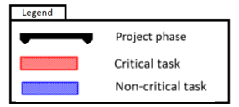
Appendices

.1 Appendix A

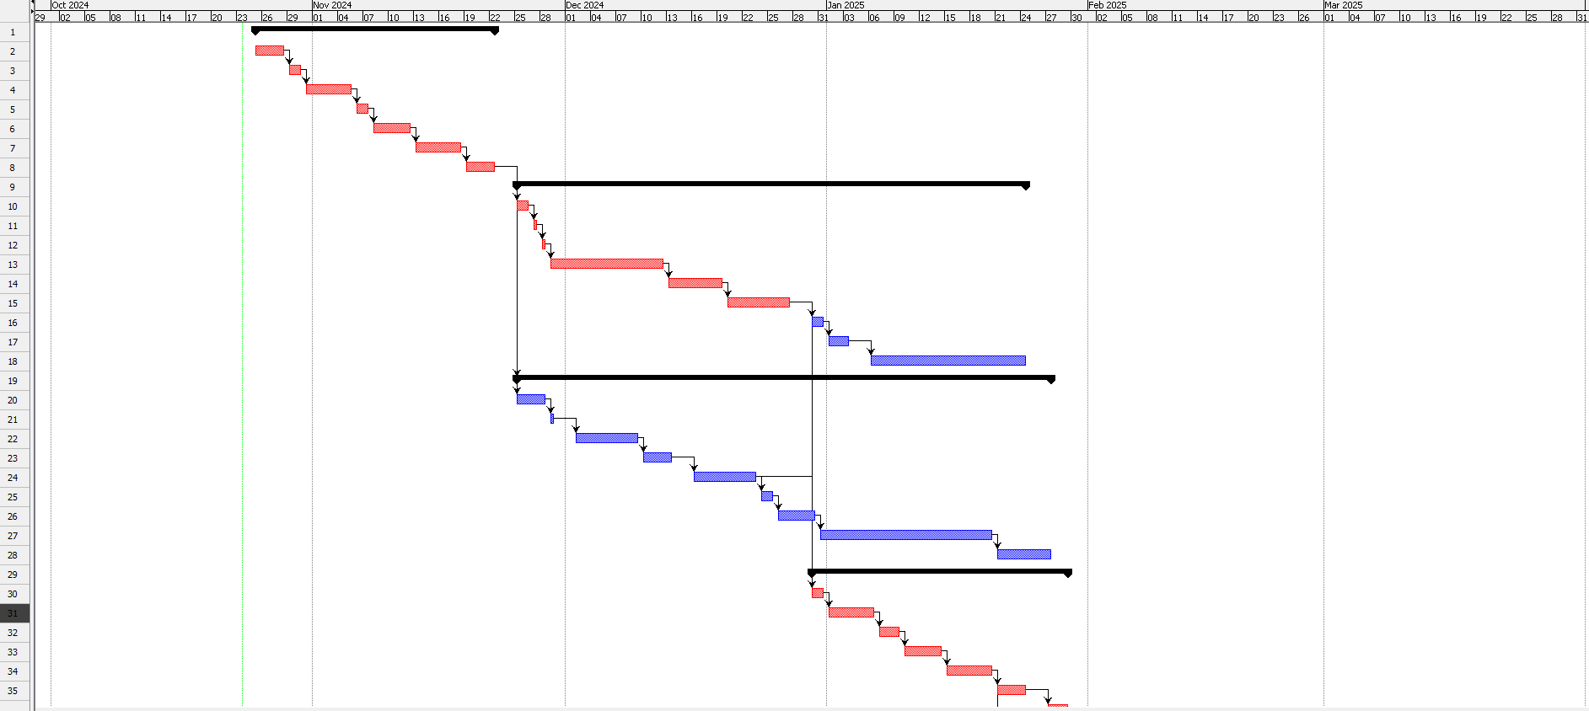
9.1.1 Gantt Chart
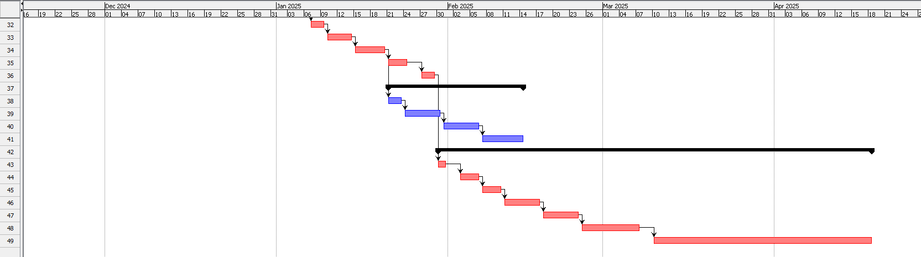
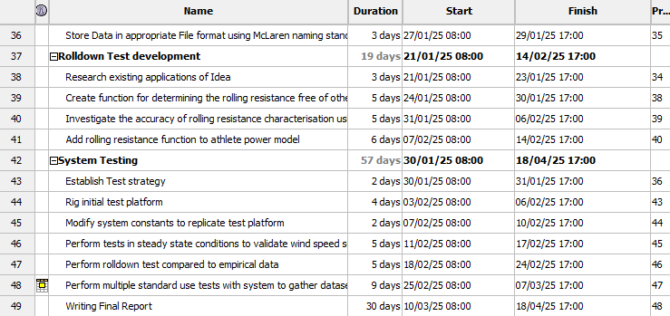
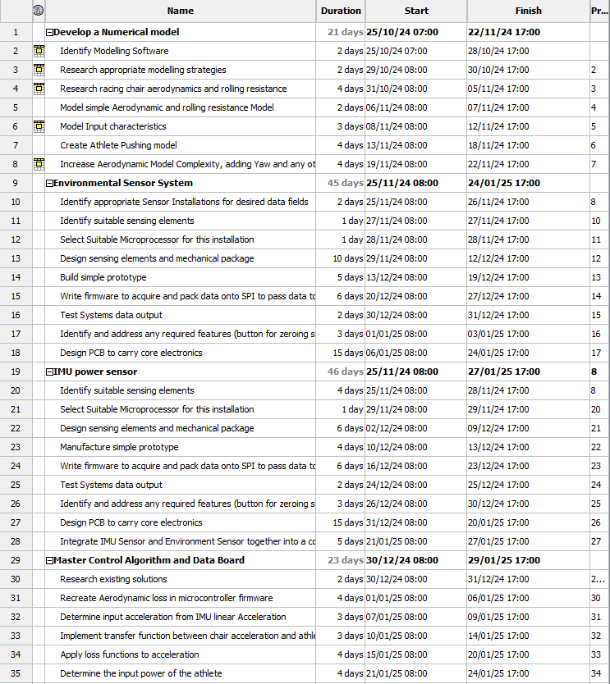

9.2 Appendix B

9.2.1 Risk Table
Table 4
Risk Number | Risk | Objective Risk  (1-6) | Consequences | Magnitude of Risk  (/5) | Risk Likelihood (/5) | Risk Factor  (/25) | Risk Management Strategy | Post Management Magnitude  (/5) | Post Management Likelihood  (/5) | Post Management Risk Factor (/25)
1 | Fall behind Schedule | 1, 2, 3, 4, 5, 6 | It will make it hard  to complete tasks in  time before specified  deadlines and catching up will become difficult. | 5 | 3 | 15 | Over predict task timings to leave large timeline overlaps. Allowing for timing overshoot without effecting the total timeline | 5 | 2 | 10
2 | Component Leadtime | 2, 3, 6 | Components won’t be available to begin intermittent test phases, or Development. | 4 | 4 | 16 | Order Components as early as possible, make early establishment of the system BOM | 4 | 2 | 8
3 | Loss or Corruption of data | 4, 6 | System Model and system firmware codebases can be lost or corrupted, needing remaking and severely damaging timeline | 5 | 2 | 10 | Using GIT to version control and hold data in a redundant server system and off local disk. Allowing for roll back if data becomes corrupt. | 1 | 1 | 1
4 | Existing Research not available | 1 | Modelling the system behaviour could become very difficult and hard to prove validity | 3 | 2 | 6 | - | 3 | 2 | 6
5 | Unable to access or determine appropriate testing platform | 6 | Without Testing the system with appropriate environment, the output data and firmware calibration is untrustworthy. | 5 | 2 | 10 | Define appropriate analogous test system that will allow for adequate calibration for proof of concept. | 5 | 1 | 5
6 | Issues with Component Integration | 2, 3 | Chosen components may prove difficult to integrate | 3 | 3 | 9 | Chose Components from similar manufacturers to aid integration | 3 | 2 | 6
7 | Inaccurate Data input data from collected research | 1, 5, 6 | As this sensor and firmware will require estimation of aerodynamic variables these Estimations will not be sound | 4 | 3 | 12 | Only using peer reviewed and cited articles and data from reputable journals and books | 4 | 1 | 4
8 | Accuracy Requirements not achievable | 6 | Post testing the environmental data is not appropriately accurate to produce useful data for use in athlete training | 5 | 4 | 20 | Do what’s possible to optimise the testing process testing early and often on all individual components where possible | 5 | 2 | 10
9 | Testing Failure | 6 | Final data and conclusion may be spurious | 5 | 4 | 20 | Do what’s possible to optimise the testing process testing early and often. Where possible validating against the mathematical model | 5 | 2 | 10

